SIMATS ENGINEERING

ASSESSMENT TOOL 3

COURSE NAME: Database Management Systems COURSE CODE: CSA0501

NAME : J Jaslin

Reg no : 192321175

COURSE OUTCOME COVERED

CO1: Analyze DBMS architecture, different data models, schema types, and design ER/EER diagrams, relational schemas for case-based scenarios by identifying entities and relationships. (BL1, BL2)

Activity Tool : Technical Presentation (Low) Assessment Tool Weightage: 35%

Dr

QUESTIONS Total Marks: 50
Q.No | Question | Bloom's Level | Marks
1 | Prepare a 5-slide presentation introducing DBMS: definition, objectives, advantages, and real-world applications. | BL2 – Understand | 5
2 | Present a comparison between file-based systems and DBMS using real-life case studies from banking or healthcare. | BL2 – Understand | 5
3 | Deliver a presentation explaining the three-level ANSI/SPARC architecture using diagrams and practical examples. | BL2 – Understand | 5
4 | Present the different data models (Hierarchical, Network, Relational) with diagrams and industry use cases. | BL1 – Remember | 5
5 | Create and present an ER diagram for an Online Library System, explaining each component clearly. | BL2 – Understand | 5
6 | Prepare a presentation on the EER model, demonstrating generalization and specialization with a University case study. | BL2 – Understand | 5
7 | Present the concept of data independence (logical and physical) and its significance in DBMS architecture. | BL2 – Understand | 5
8 | Deliver a technical presentation on the software components of a DBMS, explaining query processor, storage manager, and | BL1 – Remember | 5

 | transaction manager.
9 | Prepare a presentation comparing strong and weak entities in ER modeling with real-world examples. | BL2 – Understand | 5
10 | Present a complete design walkthrough of an EER diagram for a Retail Chain Management System. | BL2 – Understand | 5

Code of Conduct:

I J Jaslin/192321175 (Name / Reg No) certify that this submission is my original work and that I have adhered to the guidelines specified for this assessment. I understand that any violation of academic integrity rules will result in disciplinary action.

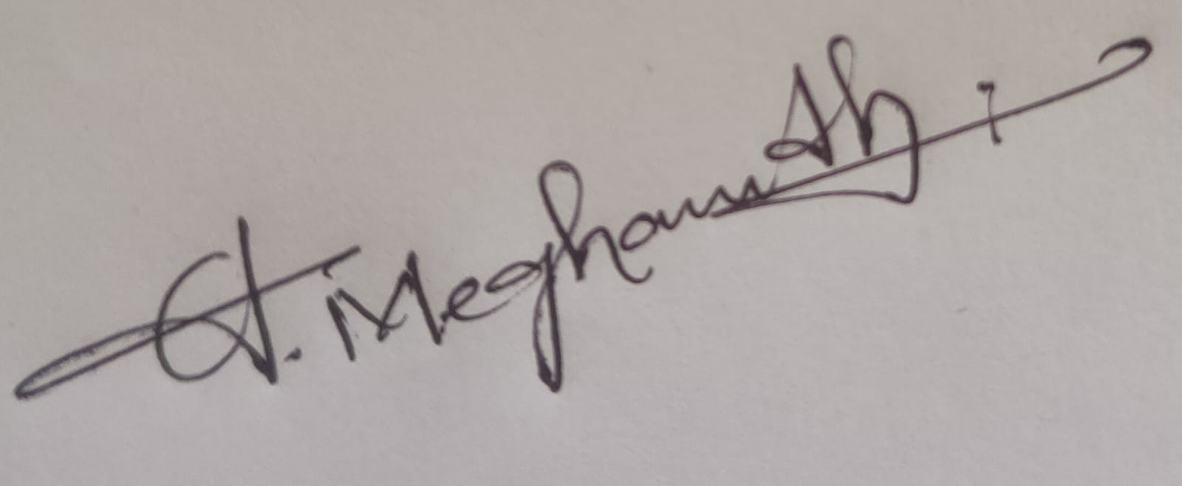
Signature of the student:

RUBRICS FOR CALCULATION:

Technical Presentation
Criteria | Weightage | Level 4 – Exemplary | Level 3 – Proficient | Level 2 – Developing | Level 1 – Beginning
Technical Content Accuracy | 30 | Highly accurate, in-depth, and  insightful technical  explanation | Technically correct content with adequate depth and clarity | Basic concepts presented with limited accuracy and depth | Content contains major  technical errors; concepts poorly understood
Problem Identification | 25 | Problem rigorously analyzed using appropriate and advanced methods | Problem clearly defined with a  logical engineering approach | Problem identified but analysis or methodology is weak | Problem statement unclear or incorrect; no logical approach
Use of Tools | 20 | Advanced tools, well-analyzed data, and highly effective visuals | Appropriate tools and data used effectively with clear visuals | Limited use of tools and basic data interpretation | Minimal or incorrect use of tools and data; poor visuals
Communication | 15 | Highly engaging, confident, and audience-focused delivery | Clear, organized, and professional communication | Understandable but lacks clarity, structure, or confidence | Poor organization, unclear speech, ineffective slides

Professionalism | 10 | Exemplary professionalism, leadership, and ethical awareness | Professional conduct with effective team collaboration | Basic professionalism; uneven team participation | Lacks professionalism; minimal contribution or  ethical awareness

1. UPS Product Tracking Information System (ER Diagram)
Entities
Shipped_Item
- Item_Number (PK)
- Weight
- Dimensions
- Insurance_Amount
- Destination
- Final_Delivery_Date
Retail_Center
- Center_ID (PK)
- Type
- Address
Transportation_Event
- Schedule_Number (PK)
- Type (Flight/Truck)
- Delivery_Route
Relationships
- Retail_Center receives Shipped_Item (1:M)
- Shipped_Item moves through Transportation_Event (M:N)
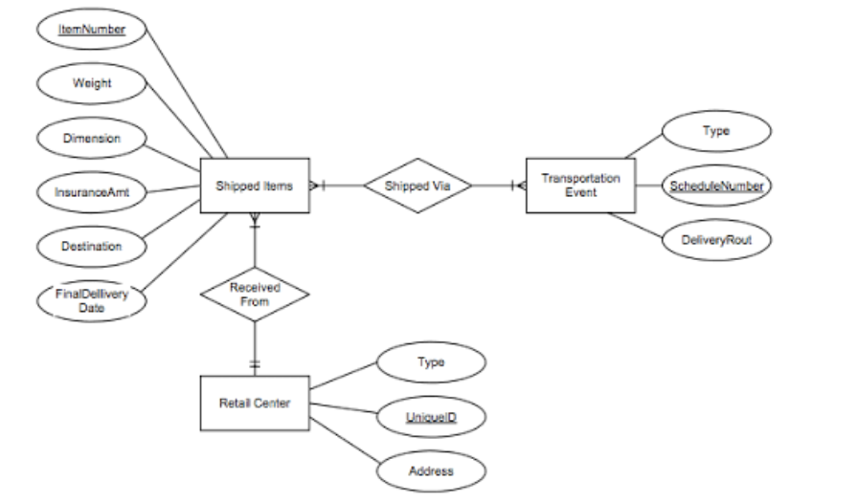
2. Course Management System (ER Diagram)
Entities
Course
- Name (PK)
- Department
- Course_Number
Section (Weak Entity)
- Section_Number (Partial Key)
- Enrollment
Room
- Room_Number (PK)
- Capacity
- Building
Exam
- Time
Relationships
- Course has Section (1:M)
- Section scheduled in Room (M:1)
- Section has Exam (1:1)

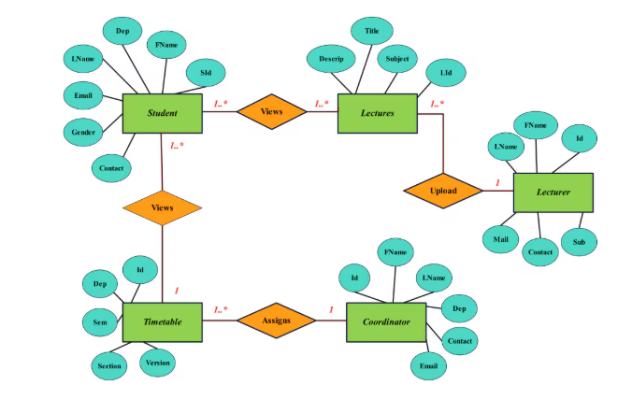

3. University Registrar's Office Management System
Entities
Course
- Course_No (PK)
- Title
- Credits
- Syllabus
- Prerequisites
Course_Offering
- Year
- Semester
- Section_No
- Timings
- Classroom
Student
- Student_ID (PK)
- Name
- Program
Instructor
- Instructor_ID (PK)
- Name
- Department
- Title
Relationships
- Course → Course_Offering (1:M)
- Instructor → Course_Offering (1:M)
- Student ↔ Course_Offering (M:N)
- Relationship attribute: Grade
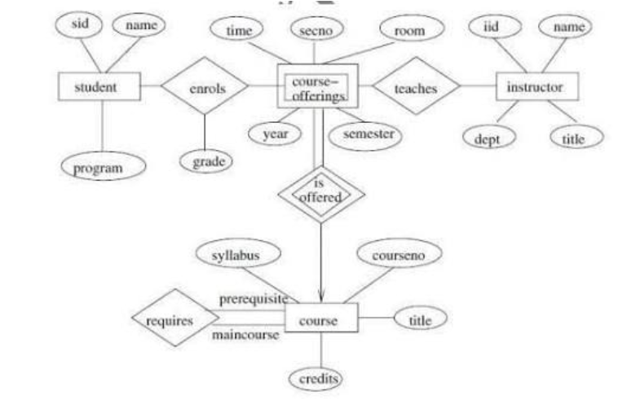
4. Hospital Management System
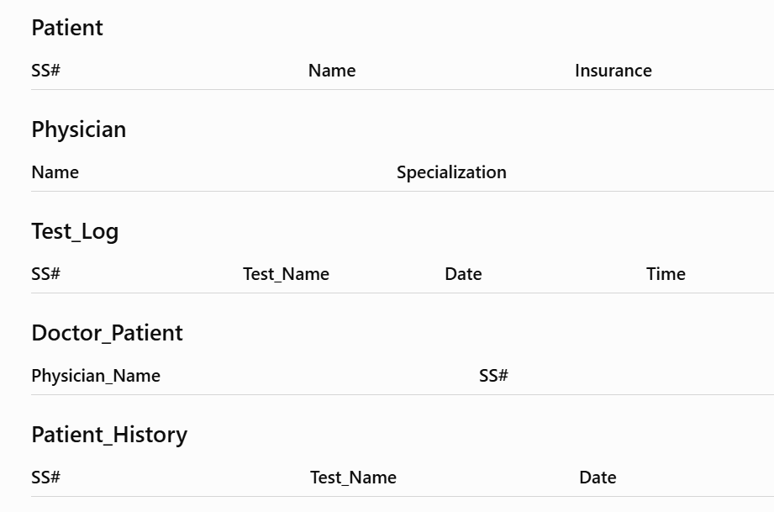
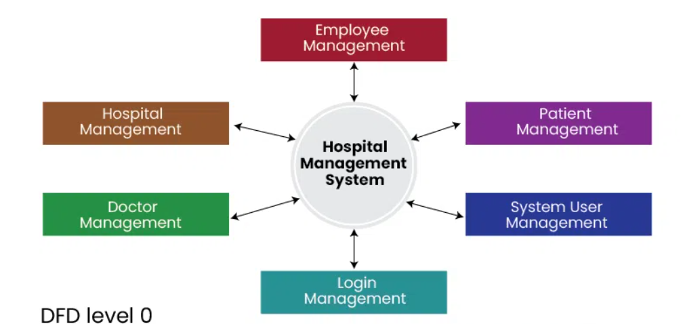

5. Company Project Management System
Entities
Department
- Dept_Name (PK)
Employee
- SSN (PK)
- Name
- Address
- Salary
- Sex
- Birth_Date
Project
- Project_No (PK)
- Project_Name
- Location
Dependent
- Dependent_Name
- Birth_Date
- Relationship
Relationships
- Department employs Employees (1:M)
- Department controls Projects (1:M)
- Employee works on Projects (M:N)
- Employee supervises Employee (1:M)
- Employee has Dependents (1:M)
- Employee manages Department
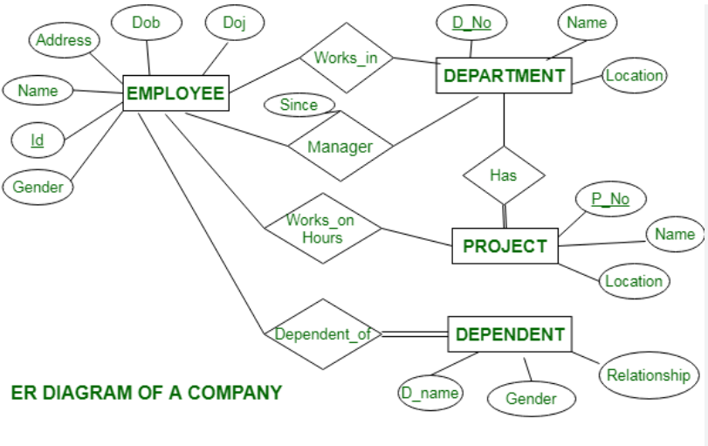

6. Schema and Instance
Schema
A schema is the overall design or blueprint of the database. It defines tables, attributes, relationships, and constraints.
Example
Student(Student_ID, Name, Department)
This structure is called the schema.
Instance
An instance is the actual data stored in the database at a particular time.
Example
Student_ID | Name | Department
101 | Rahul | CSE
102 | Anita | ECE

Types of Schema
Logical Schema | Physical Schema | View Schema
Defines tables and relationships. | Defines how data is stored on disk. | Defines what users can view.
Used by DB designers. | Used by system administrators. | Used by end users.
Independent of storage. | Depends on storage. | Shows only required data.

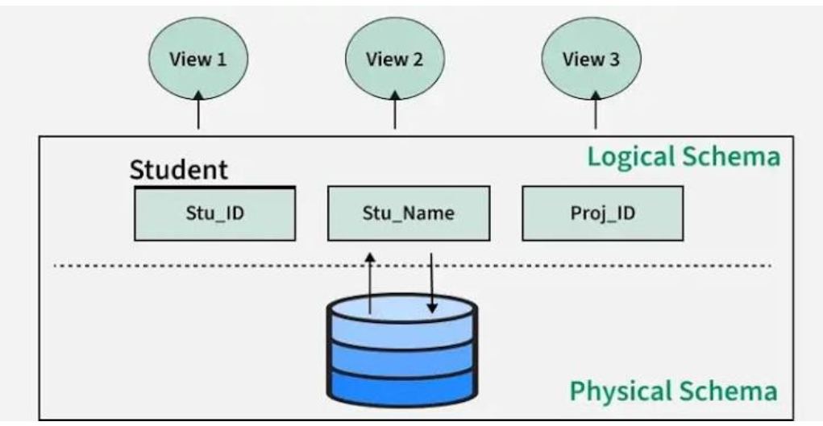

7. Bank Management System
Entities
Customer
- Customer_ID
- Name
- Address
- Phone
Account
- Account_No
- Type
- Balance
Loan
- Loan_No
- Amount
Branch
- Branch_ID
- Name
- Location
Relationships
- Customer owns Account
- Branch maintains Account
- Customer takes Loan
- Branch issues Loan

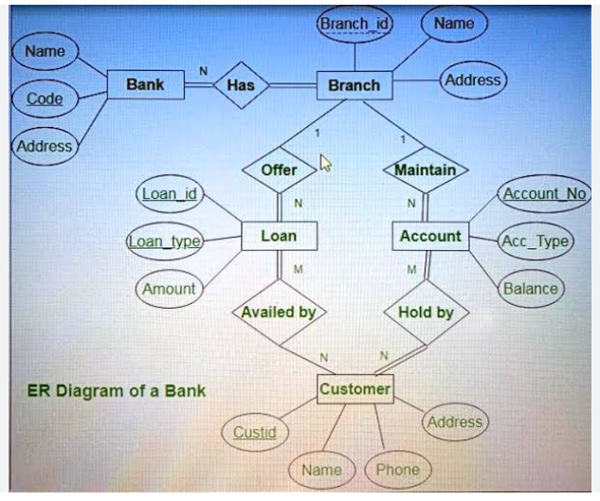

8. Extended ER (EER) Model
The Extended Entity Relationship (EER) Model is an extension of the ER model that supports more advanced database concepts such as inheritance and higher-level abstractions.
Generalization
- Combines multiple lower-level entities into one higher-level entity.
- Example:
  - Savings Account
  - Current Account
  - → Account
Specialization
- Divides one entity into multiple specialized entities.
- Example:
  - Employee
    - Manager
    - Engineer
    - Clerk
Aggregation
- Treats a relationship as a higher-level entity so it can participate in another relationship.
- Example:
  - Employee works on Project.
  - This "Works_On" relationship can be aggregated and linked to another entity like Department.

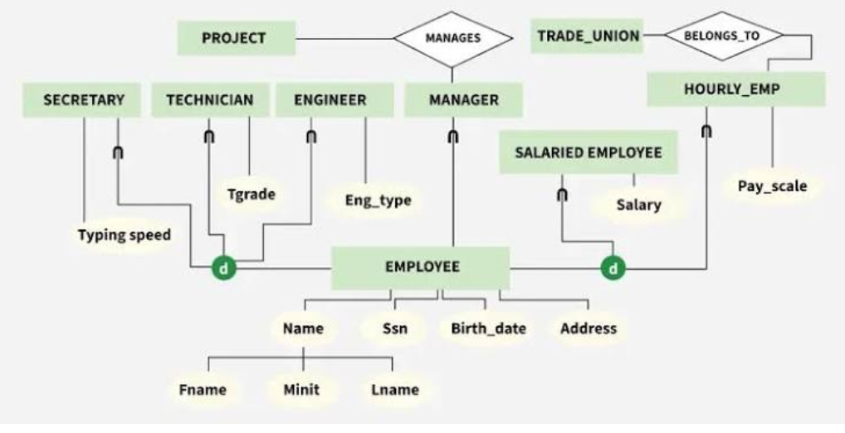

9. EER Diagram for Hospital Management System
Superclass
Person
- Person_ID
- Name
- Address
Subclasses
Patient
- Insurance_No
- Age
Doctor
- Specialization
- Experience
Weak Entity
Medical_Record
- Record_No (Partial Key)
- Test_Name
- Date
- Diagnosis

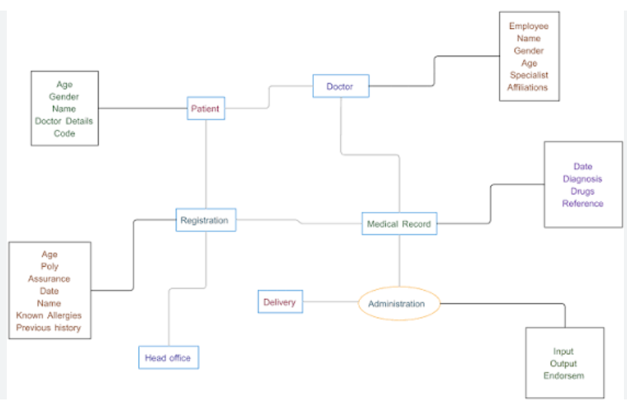

10. Role and Responsibilities of a DBA
A Database Administrator (DBA) is responsible for managing, maintaining, and securing the database system to ensure efficient and reliable operation.
Responsibilities
- Install and configure the DBMS.
- Create and maintain databases.
- Manage user accounts and permissions.
- Perform backup and recovery.
- Ensure database security.
- Monitor and optimize database performance.
- Maintain data integrity and consistency.
- Handle database updates and upgrades.
- Troubleshoot database issues.
- Support developers and end users.
